 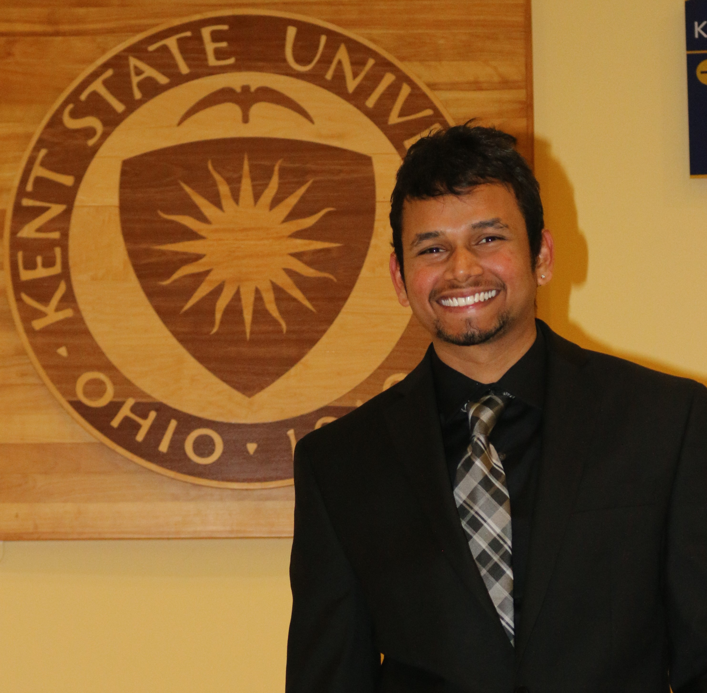

Masters student actively seeking for a full time position

**PAVAN**

**SARISA**

working balance

GITAM University

Visakhapatnam, India.

**Bachelors: Information Technology**

**Masters: Software Development**

EDUCATION

Built an e-commerce website that resembles websites like Amazon, E Bay. Collected the requirements, setup the tools, designed wire frames, created web pages, laying down ER Diagrams, implemented a database, populating or retrieving data from post and get services respectively.

Technologies Used: HTML5, CSS3, JavaScript, JQuery, JSON, T-SQL.

The main goal of this project is to design a database for online course registration which includes the Implementation functionalities pertaining to a database administrator which involved creating schema, ER Diagrams, tables. Implemented the features using PL/SQL procedures and functions.

Technologies Used: Oracle 10g, Oracle SQL Developer.

It is a snapbook consists of images and given a like or unlike option developed in Angular JS framework where the images are showed up in the view, controller is used to store an array containing the objects and directives are used to simplify the code.

Technologies: HTML, CSS, JavaScript, Angular JS, Bootstrap.

Hyderabad, India

Developed an application using Angular JS, where I have built a location-based service using a third-party custom directive in which I will fetch the data from Wikipedia API and display it to the map. I have mapped URL’s to different views using routing. Technologies: Angular JS, Bootstrap, HTML, CSS.

I am self-motivated masters student specializing in Software Development, at Kent State University, Kent, which I am interested in Web Development in turn act as a Web Developer.

**50**

**25**

**25**

Graphic

Design

UX Design

Web

Development

PROFESSIONAL SKILLS

HTML/CSS

JavaScript/jQuery

ASP.NET

Angular JS

Bootstrap

WordPress

**90**

**80**

**70**

**75**

**75**

**80**

**50**

**65**

**70**

Photoshop

Illustrator

InDesign

PROGRAMMING LANGUAGES

**80**

**75**

**85**

C#

C

PORTFOLIO

username

**Tel:**

**Email:**

**Address:**

sarisapavan@gmail.com

1654 ASPEN CT, APT#137

Kent, OH-44240.

+1 (864)-365-8732

WHO AM I?

HOBBIES & INTERESTS

**2010 - 2014**

**2014 - 2016**

Kent State University

Kent, OH

Kent, OH

**database setup for Online course registration** at Kent State University.

**January 2015 / May 2015**

Kent, OH

**shopping cart** at Kent State University.

**August 2015 / December 2015**

**May 2016**

**SNAP BOOK.**

Kent, OH

Kent, OH

**NEARME APP.**

**May 2016**

**July 2012 – December 2013**

**Web developer – intern, *coign it services***

WORK EXPERIENCE

**SMITH**

**More info on:**

linkedin.com/AdamSmi



Designed and development of various components and modules of the application using Visual studio. Used C# language in developing the Business logic, where in extensively implemented the Object Oriented Programming concepts. Worked primarily on Web development technologies using: HTML, CSS, JavaScript, jQuery. Involved in writing several SQL Server stored procedures, functions and triggers for all the DML functionality.

 DESIGNING

PL/SQL

**\*References will be given upon request\***

Pencil Art Photography Travelling Cricket Cooking

**  C:\Users\pavan sarisa\AppData\Local\Microsoft\Windows\INetCache\Content.Word\1468446640_road.png  **

Pavan S <http://pavansarisa.com/>

